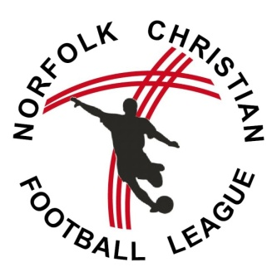
NCFL Acceptance of Rules Agreement: 2019/20 Season
Form 3

Rules Binding on Clubs
Each member club shall be deemed to have given its assent to the foregoing rules and agreed to abide by the decisions of the Management Committee subject to rule 16. Each member club must abide by any issued Football Association code of conduct.

Agreement to be Signed
The Chairman and the Secretary of each club shall complete and sign the following agreement which shall be deposited with the NCFL General Secretary together with the application for membership for the coming season, or upon indicating that the Club intends to compete.

"We (name of chairman) __________ __ __ ____ (signed) ____ _____ _ and

(name of secretary) ______________________________ (signed) ___ of the

Football Club,

have been provided with a copy of the rules and regulations of NCFL and do hereby agree for and on behalf of the said Club, if elected or accepted into membership, to conform to those rules and regulations and to accept, abide by and implement the decisions of the Management Committee of the Competition, subject to the right of appeal in accordance with rule 16.
Any alteration of the chairman and/or secretary on the above agreement must be notified to Norfolk FA and to the NCFL General Secretary.

NCFL Care of Trophies: 2019/20 Season

Trophies: Legal Owners, Conditions of Temporary Ownership and Issued Awards
If a Competition is discontinued for any reason a trophy or any other presentation shall be returned to the donor if the conditions attached to it so provide or, if not, dealt with as the sanctioning Association may decide.
The following agreement shall be signed on behalf of the winners of the cup, or trophy or league shield:-

“We (name of chairman) ___________________________ (signed) ____________________________and

(name of secretary) _______________________________ (signed) _______________________ ___of the

_______________________________________________Football Club, members of and representing the

club, having been declared winners of _____________________ ____________ Cup, League Shield or Trophy, and it having been delivered to us by NCFL, do hereby on behalf of the club jointly and severally agree to return the cup, league shield or trophy to the Competition adult League secretary or general secretary/administrator on or before 1st February 2020.

If the cup or trophy is lost or damaged whilst under our care we agree to refund to NCFL the amount of its current value or the cost of its thorough repair. Failure to comply will result in a fine as determined by the Management Committee. At the close of each competition awards may/shall be made to the winners and runners-up if the funds of the Competition permit.

